**Project Guide**

Restaurant Ecommerce Site

Submitted By:

Janine Magayanes

[janine.magayanes@code.berlin](mailto:janine.magayanes@code.berlin)

Summer Semester 2020

**Brief Overview:**

Otito is Japanese Restaurant in Berlin that offers a wide variety of menu. It currently has an active website but the features are limited and the design is outdated.

Objective:

1. Redesign the Restaurant Website into a more modern and sophisticated look that will attract potential customers.
2. Introduce a feature for e-commerce where potential customers can view products that are available for delivery.
3. Create an admin interface where a staff admin can update products and promotions.

**Admin User Process**

Once a super user is created, an admin staff can login to the site’s admin interface

**Login Page**

Local Url:<http://127.0.0.1:8000/admin/login/?next=/admin/>

Current Url: <https://otito.herokuapp.com/admin/login/?next=admin/>

Image:

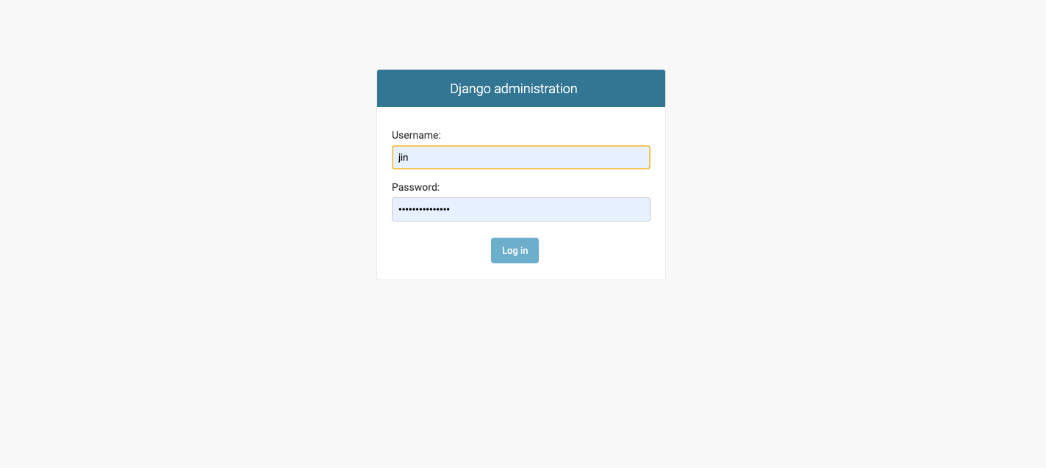

Key in the username and password

2. **Home Page**

Url: <https://otito.herokuapp.com/admin/>

Image:

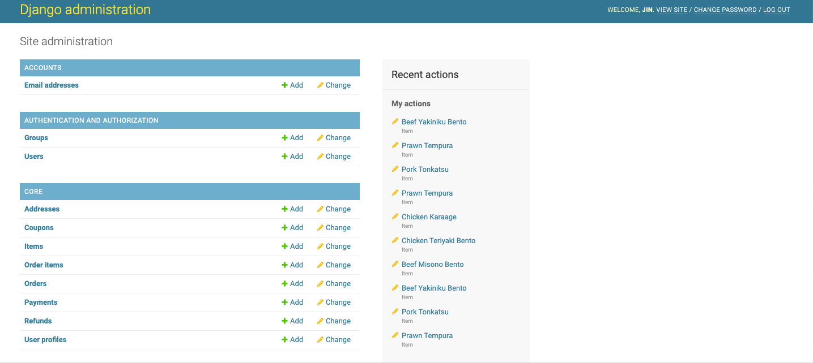

Contains all the items that can easily be updated by clicking the Add or Change button

4. I**tem List Page**

Url: <https://otito.herokuapp.com/admin/core/item/>

Image:

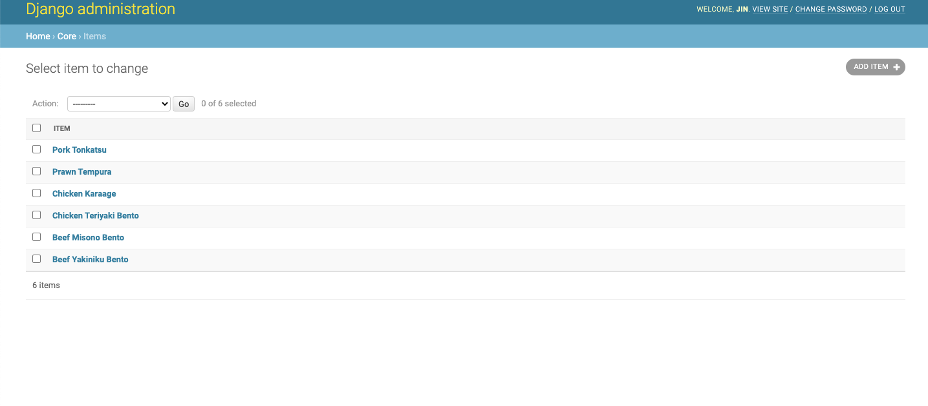

List of all the current products on sale. The product items can also be updated by clicking on the names individually

5. **Update Item Page**

Url: <https://otito.herokuapp.com/admin/core/item/6/change/>

Image:

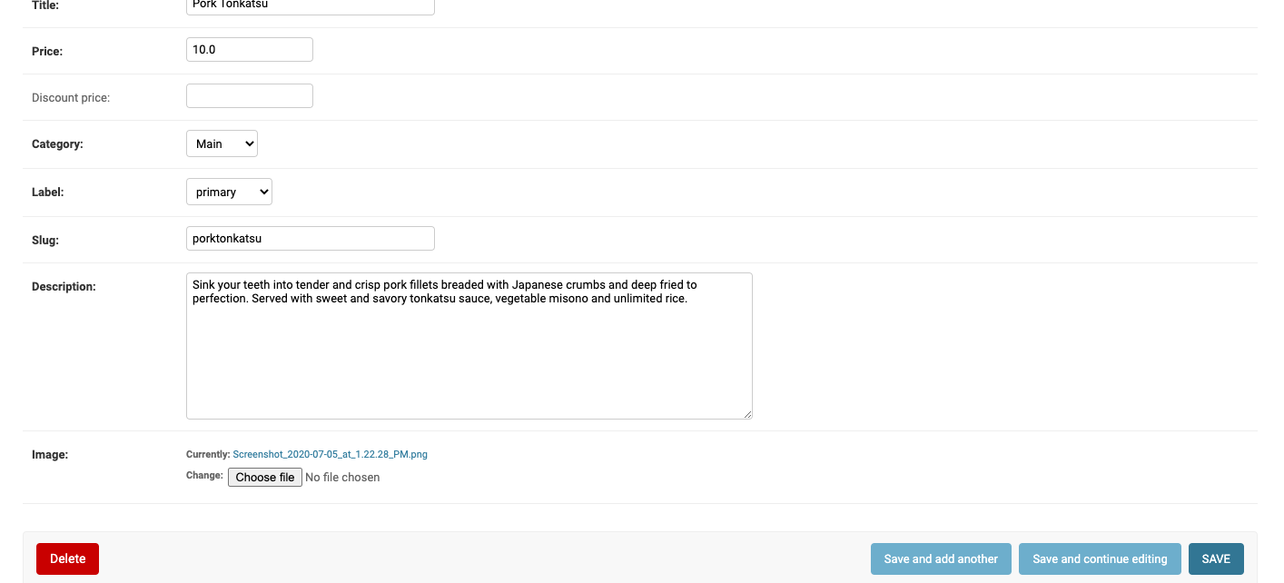

This is where the user can change the details of a specific product. There is also an option to delete it.

**End User Process (Customer)**

**1. Sign Up Page**

Url:<https://otito.herokuapp.com/accounts/signup/>

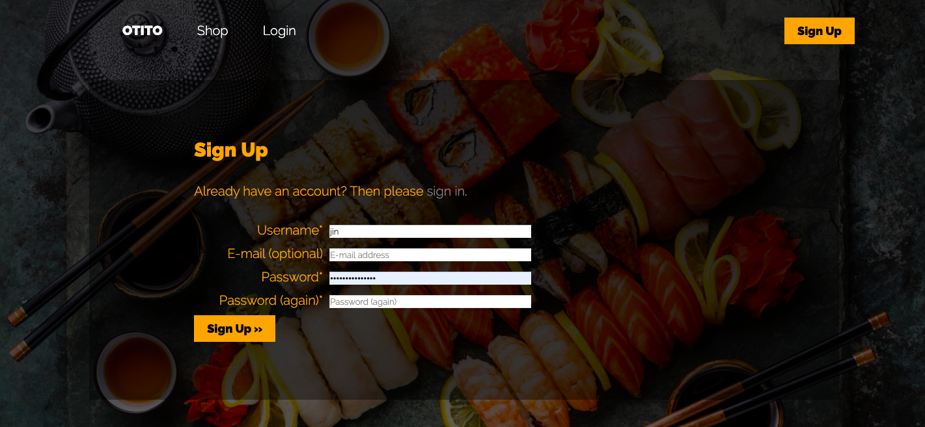

This page is where a user can sign up on the website. It is required to be able to purchase an item. After sigining up, the user will be routed to the home page

**2. Login Page**

Url: <https://otito.herokuapp.com/accounts/login/>

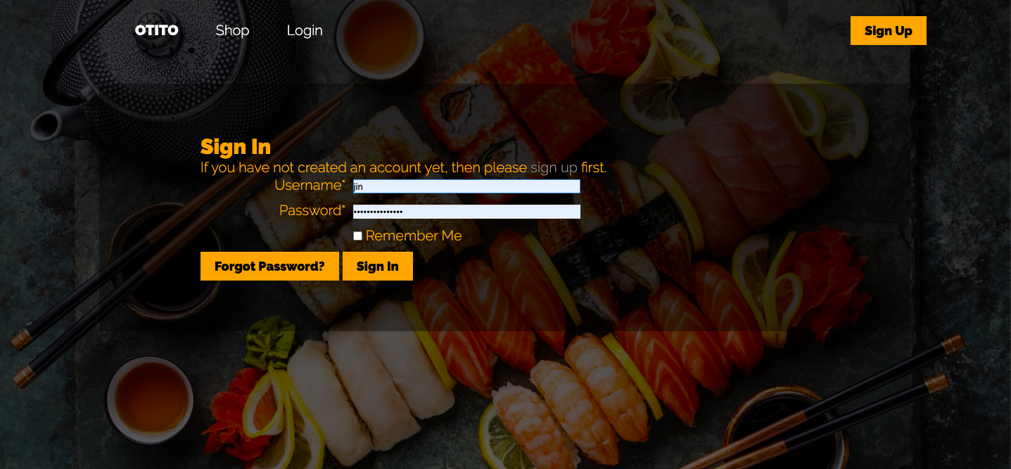

User can just log in if he has an active account.

**3. Home Page**

Url: <https://otito.herokuapp.com/>

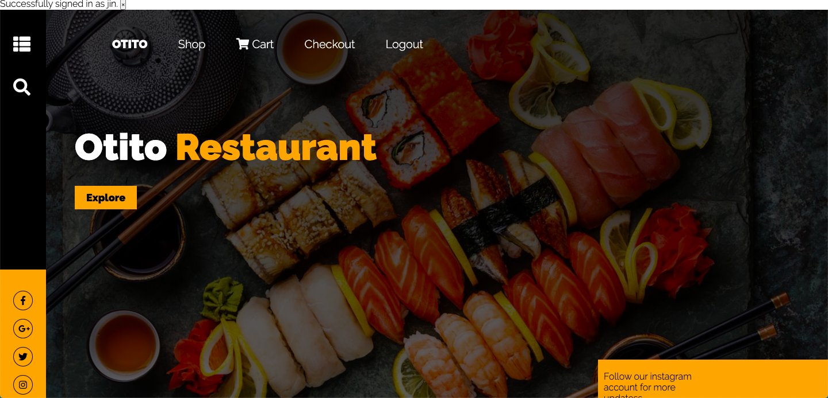

The main page. At the moment the features for the icons are not yet implemented

4. **Shop Page**

Url: <https://otito.herokuapp.com/shop>

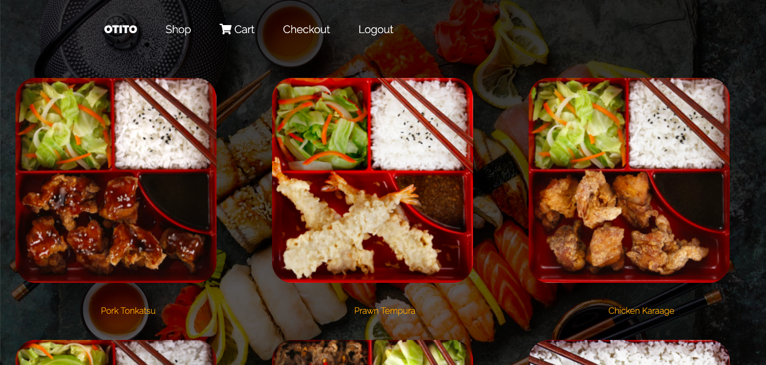

This page shows all the available items for delivery. The user can click on the photo to view the item details.

4. **Shop Page**

Url: <https://otito.herokuapp.com/product/porktonkatsu/>

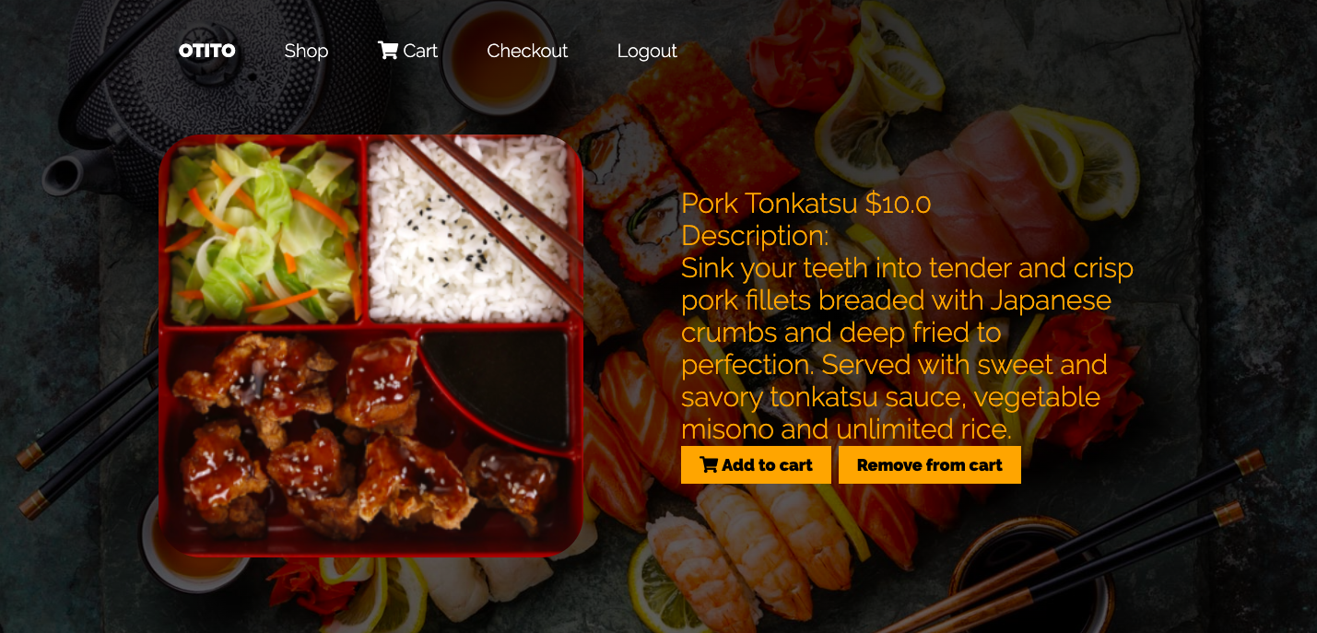

This page shows the item description and the option to add/ remove it to the shopping cart

**5. Cart Page**

Url: <https://otito.herokuapp.com/order-summary/>

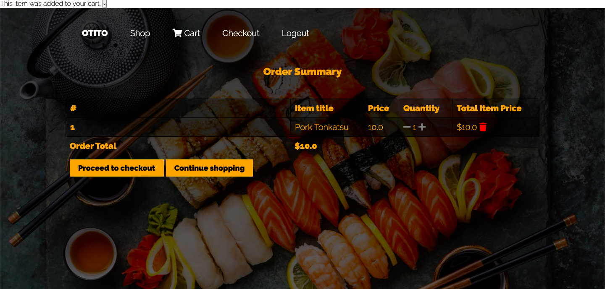

Once an item has been added, the user will be routed to the Cart Page where he can view all the current orders

**6. Checkout Page**

Url: <https://otito.herokuapp.com/checkout/>

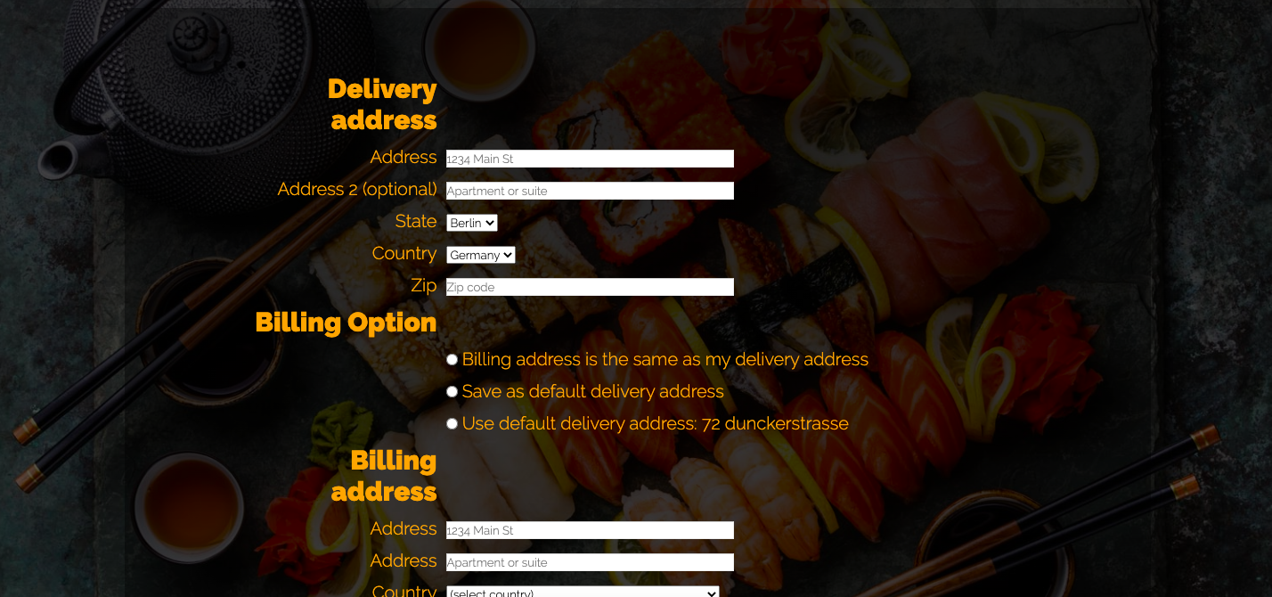

The checkout page is where the user needs to key in the delivery and billing details. This is also where he can chose to make a payment. Currently there is only one option: Stripe

**7. Payment Page**

Url: <https://otito.herokuapp.com/payment/stripe/>

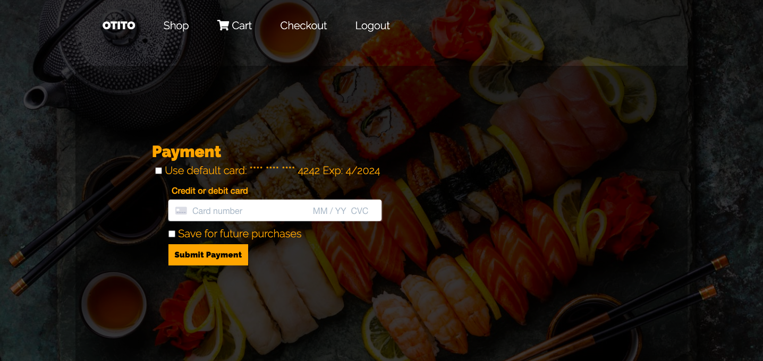

This page is where the user can provide the payment card details. There is also an option to save it, but it will not be saved in the site’s database, it will be in Stripe’s. If the payment is successful, the user will be routed to the home page and a success message.

**8. Log out Page**

Url: <https://otito.herokuapp.com/accounts/logout/>

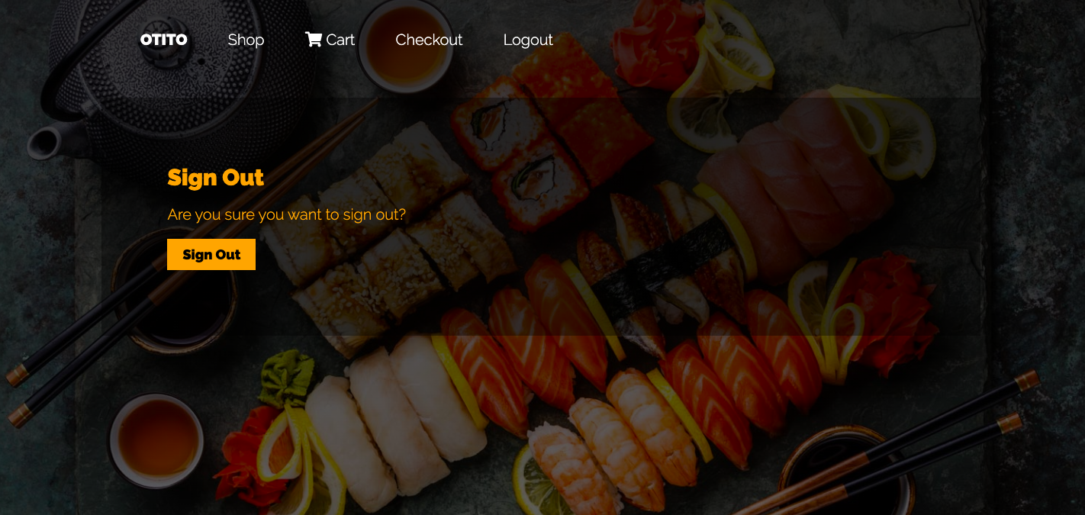

This is the page where user can log out after the transaction.